Frogs on Lily Pads

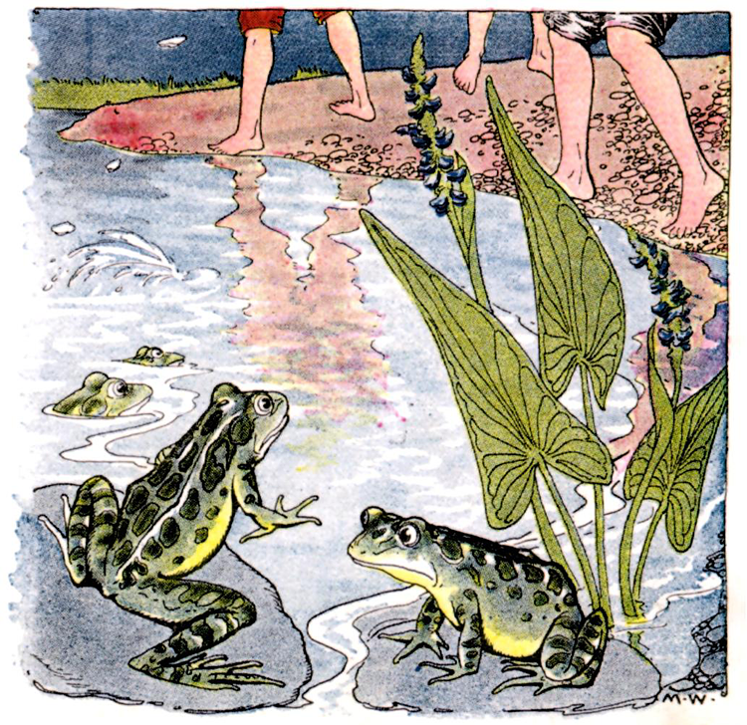

Make as many sentences as you can describing this picture.

