Science and Scientists

Scientists do many things. Match the list of words in the box with their definitions below:
do research  study  discover  hypothesize |  | observe  invent  collect data  make predictions | do experiments  make theories  solve problems  prove
__________ | To test something under controlled conditions.
__________ | To make an educated guess.
__________ | To make a guess about the future.
__________ | To gather facts.
__________ | To find something for the first time.
__________ | To make an explanation for something.
__________ | To make something for the first time.
__________ | To look at something very carefully for a period of time.
__________ | To show that something is correct or true.
__________ | To find solutions.
__________ | To learn about something (often through a book).
__________ | To investigate something and do experiments.

Unscramble these words and cross out the extra letter:
s o x r b v e e  d a l l v c o t c t e a  s r r e e c h e a  v o s c d i r e  p e v r x t e m n i  h v e n t i n  t i n z t o d e r p i c | ________________________  ________________________  ________________________  ________________________  ________________________  ________________________  ________________________

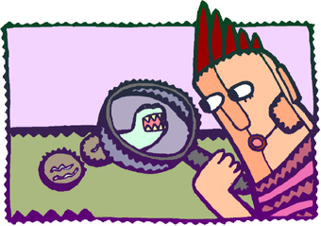 www.bogglesworldesl.com
Science and Scientists
What do these scientists do?
Try to use the phrases is a person who, is somebody who, is someone who. Also try to use as many expressions from the box on page 1 as you can.

Anthropologist  Archeologist  Astronomer  Biochemist  Biologist  Botanist  Chemist  Economist  Geneticist  Geometrician  Geographer  Geologist  Linguist  Mathematician  Meteorologist  Oceanographer  Paleontologist  Psychologist  Physicist  Sociologist  Statistician  Volcanologist  Zoologist | ________________________________________  ________________________________________  ________________________________________  ________________________________________  ________________________________________  ________________________________________  ________________________________________  ________________________________________  ________________________________________  ________________________________________  ________________________________________  ________________________________________  ________________________________________  ________________________________________  ________________________________________  ________________________________________  ________________________________________  ________________________________________  ________________________________________  ________________________________________  ________________________________________  ________________________________________  ________________________________________

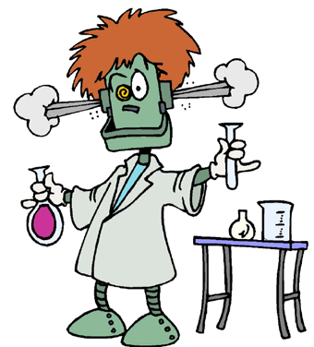 | What kind of scientist would you like to be why?  _________________________  _________________________  _________________________  _________________________  _________________________  _________________________
www.bogglesworldesl.com

