
Unscramble these pumpkins to figure out the hidden message:
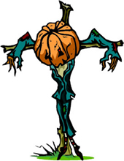 |  |  |  |  |  |  |  |  |  |  |  |  | 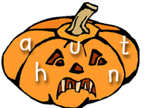 |  |  |  |  |  |  |  |  |  |  |  |  |  | 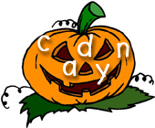
 |  |  |  |  |  |  |  |  |  |  |  |  | __ |  | __  18 |  | __  11 |  | __ |  | __  25 |  |  |  |  |  | __  2 |  | __ |  | __ |  | __  9 |  | __
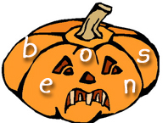 |  |  |  |  |  |  |  |  |  |  |  |  | 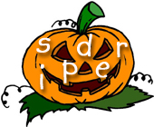 |  |  |  |  |  |  |  |  |  |  |  |  |  | 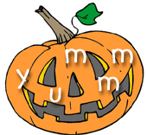
__  6 | __  23 |  | __  19 |  | __ |  | __ |  |  |  |  |  | __  17 |  | __  10 |  | __  15 |  | __  20 |  | __ |  | __  3 |  |  |  | __  5 |  | __ |  | __  12 |  | __ |  | __
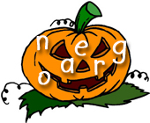 |  |  |  |  |  |  |  |  |  |  |  |  | 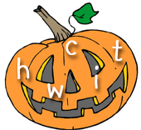 |  |  |  |  |  |  |  |  |  |  |  |  |  | 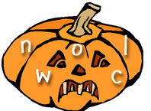
__ | __ |  | __ |  | __  16 |  | __ |  | __  8 |  |  |  | __ |  | __ |  | __ |  | __ |  | __  22 |  |  |  |  |  | __ |  | __  7 |  | __ |  | __ |  | __
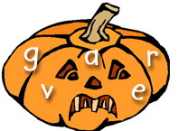 |  |  |  |  |  |  |  |  |  |  |  |  | 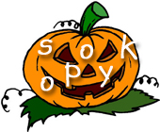 |  |  |  |  |  |  |  |  |  |  |  |  |  | 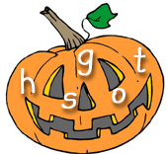
__ | __ |  | __  4 |  | __ |  | __ |  |  |  |  |  | __  1 |  | __  13 |  | __ |  | __ |  | __  14 |  | __ |  |  |  | __  21 |  | __ |  | __ |  | __  24 |  | __
Halloween Riddle: Use the numbers above to fill in the riddle.
What do monsters have for breakfast on Halloween morning?
 |  | __ |  | __ |  | __ |  | __ |  | __ |  | __ |  | __ |  | __ |  | __ |  |  |  | __ |  | __ |  | __ |  | __ |  | __ |  | __ |  | __ |  | __
 |  | 1 |  | 2 |  | 3 |  | 4 |  | 5 |  | 6 |  | 7 |  | 8 |  | 9 |  |  |  | 10 |  | 11 |  | 12 |  | 13 |  | 14 |  | 15 |  | 16 |  | 17
 |  |  |  |  |  |  |  |  |  | __ |  | __ |  | __ |  |  |  | __ |  | __ |  | __ |  | __ |  | __
 |  |  |  |  |  |  |  |  |  | 18 |  | 19 |  | 20 |  |  |  | 21 |  | 22 |  | 23 |  | 24 |  | 25

(c) 2003 www.bogglesworldesl.com

