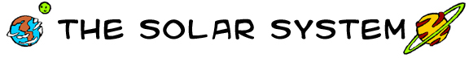
Across
2. Earth's companion.
4. The farthest planet from the sun.
5. An instrument that scientists use to observe planets.
9. This planet is known as the red planet.
11. One of many 'rocks' in a belt between Mars and Jupiter.
12. Planet between Saturn and Neptune.
14. The largest planet in the solar system.
15. Planet named after the sea god.

Down  1. Planet known as the evening star.  2. Our galaxy.  3. An icy rock that has bright tail when it comes close to the sun.  6. Our sun is this. | 7. The path that a planet takes around the sun.  8. Planet closest to the sun.  10. Planet famous for its rings.  13. Star at the center of our solar system.  16. Our planet. | 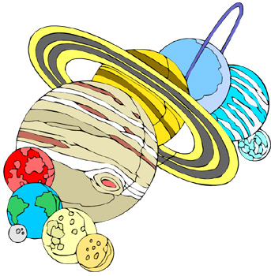
© 2006 www.bogglesworldesl.com

