A sheet There is a Rumor Going Around . . .
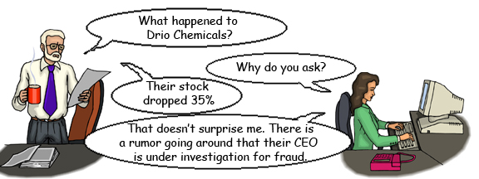
Talking About Stocks |  |  | Talking About Rumors
The stock jumped . . .  The stock dropped . . . |  |  | There is a rumor going around . . .  Rumor has it that . . .  There is some speculation that . . .
Company | Stock Change |  |  | Speculation
 | 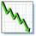 | 35% |  | Their CEO is under investigation for fraud.
 |  | 20%
 |  |  |  | They are being bought out by Kingdom Capital.
 |  | 22%
 |  |  |  | They defaulted on their loan.
 |  | 45%
 |  |  |  | They discovered a new oil field.
 |  | 58%
 |  |  |  | They are being sued for environmental damages.

www.bogglesworldesl.com
B sheet There is a Rumor Going Around . . .
Talking About Stocks |  |  | Talking About Rumors
The stock jumped . . .  The stock dropped . . . |  |  | There is a rumor going around . . .  Rumor has it that . . .  There is some speculation that . . .
Company | Stock Change |  |  | Speculation
 |  | 35% |  | Their CEO is under investigation for fraud.
 |  |  |  | They are being sued for negligence.
 |  | 150%
 |  |  |  | They are going to merge with JKL Bank.
 |  | 70%
 |  |  |  | Labor negotiations failed so the steel plants will shut down.
 |  | 250%
 |  |  |  | They are going to be awarded a huge government contract.
 |  | 90%

www.bogglesworldesl.com

