Fill in the blanks below with words from this box:
migrate  beluga whales  fur  arctic foxes  warm  Arctic  air | holes  walruses  shorter  polar bears  pole  extinct  Ocean |  | below  arctic tern  drop  blubber  ice pack  energy  keeping

Keeping Warm
Temperatures in the Arctic drop far ___________ zero. And so, animals have adapted to stay warm. In the Arctic _____________, marine animals such as __________________ and __________________ have a thick layer of fat called _________________. Blubber is important because it helps the animals stay ________________ and store ________________. Land animals such as __________________ and __________________ have a thick coat of hair called ________________. In fact, polar bear fur is so good at __________________ heat in that when you look at a polar bear with an infrared (heat) camera you see almost nothing.

Migration
When the temperature begins to _____________ and the days become ______________, some animals _______________ for the winter, which means they head south to warmer areas. The ______________ is an amazing bird that travels from pole to ______________ twice each year so that it spends the summer in the _______________ and the winter in the Antarctic.

Life on the Ice Pack
During the _______________, much of the ocean in the Arctic is covered in ice. This large mass of ice is called the _______________. Animals have adapted to living and traveling on the ice pack. Seals use _______________ in the ice to
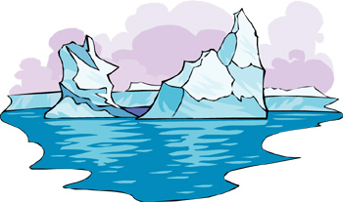 |  | travel from the surface to find food in the cold Arctic waters below. Polar bears wait by these holes for seals to come up for _______________. If the ice pack disappears, polar bears will have difficulty hunting and may become _______________.
© 2006 www.bogglesworldesl.com

