Antonyms  Match the words with their antonyms. |  |  | 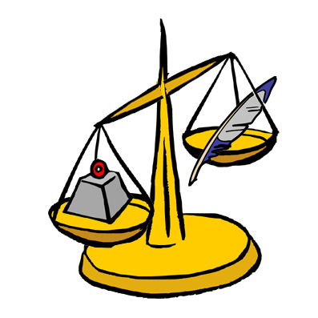
 |  |  |  |  | 
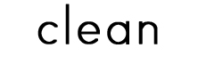 |  |  |  |  | 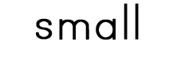
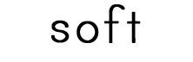 |  |  |  |  | 
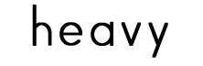 |  |  |  |  | 
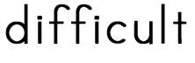 |  |  |  |  | 
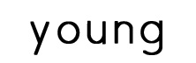 |  |  |  |  | 
 |  |  |  |  | 
 |  |  |  |  | 
 |  |  |  |  | 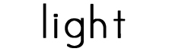
 |  |  |  |  | 
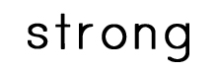 |  |  |  |  | 
 |  |  |  |  | 
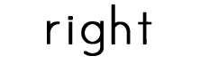 |  |  |  |  | 
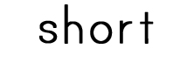 |  |  |  |  | 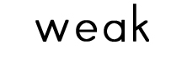

©2011 Lanternfish ESL
www.bogglesworldesl.com

