Jobs matching and Writing
Match the jobs below with their pictures and then practice writing the name of the job.
 |  |  |  | 
 |  |  |  | 
 |  |  |  | 
 |  |  |  | 
 |  |  |  | 
 |  |  |  | 
 |  |  |  | 
 |  |  |  | 
 |  |  |  | 
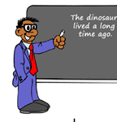 |  |  |  | 
©2009 www.bogglesworldesl.com

