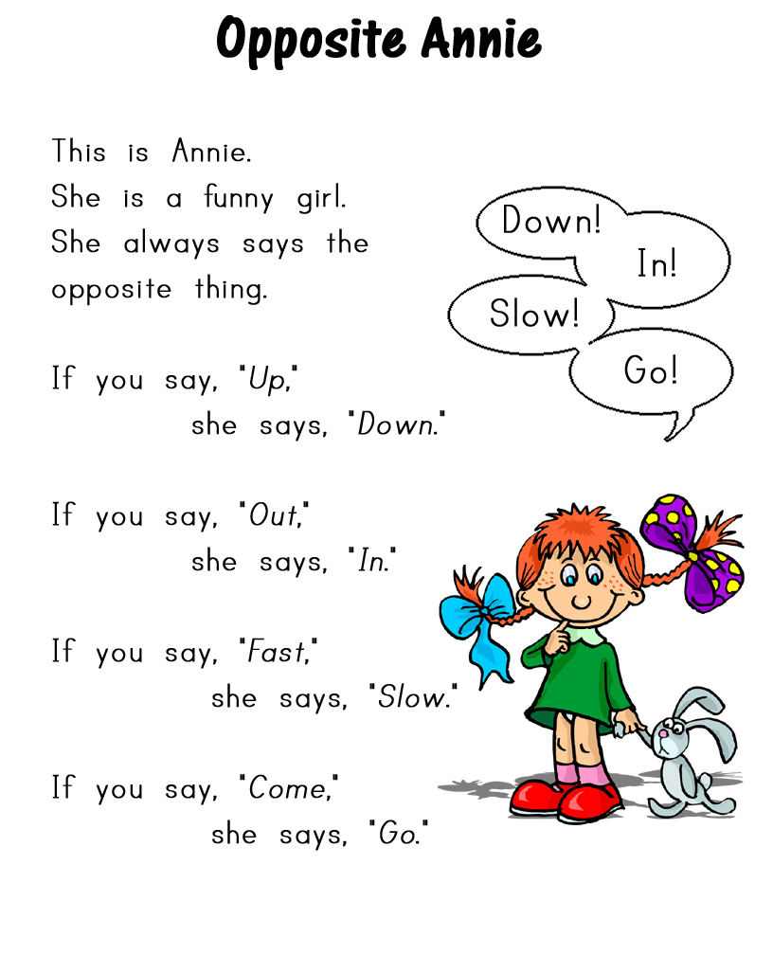

© 2010 Lanternfish ESL
www.bogglesworldesl.com

Match the opposites.
 |  |  | 
 |  |  | 
 |  |  | 
 |  |  | 
 |  |  | 

Writing Practice: What will Opposite Annie say?









© 2010 Lanternfish ESL
www.bogglesworldesl.com

