 |  |  | 

 |  |  | 

© 2009 Lanternfish ESL at www.bogglesworldesl.com

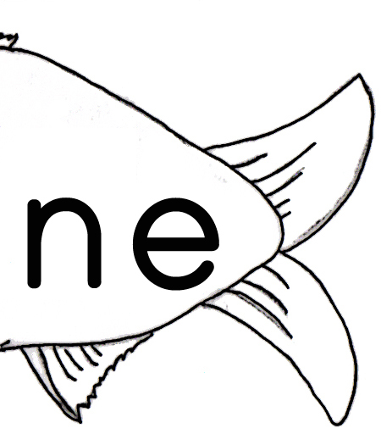 |  |  | 

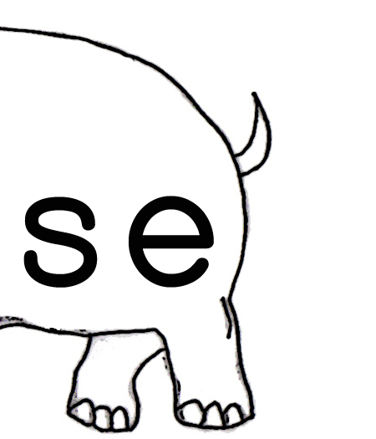 |  |  | 

© 2009 Lanternfish ESL at www.bogglesworldesl.com

 |  |  | 

© 2009 Lanternfish ESL at www.bogglesworldesl.com

© 2009 Lanternfish ESL at www.bogglesworldesl.com

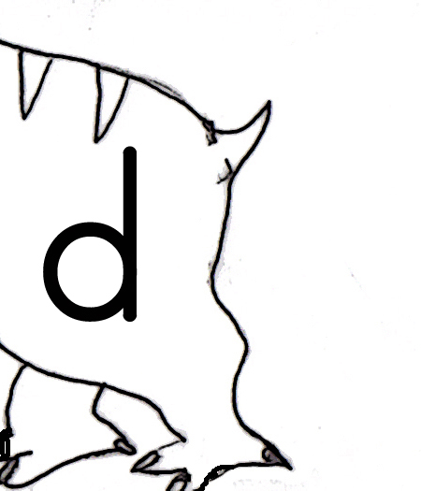 |  |  | 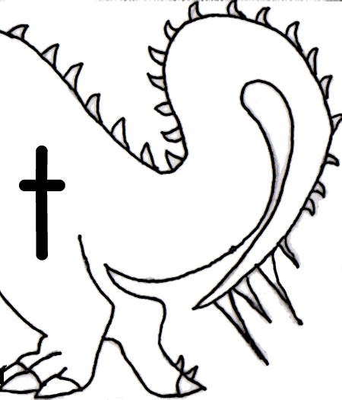

© 2009 Lanternfish ESL at www.bogglesworldesl.com

 |  |  | 

 |  |  | 

© 2009 Lanternfish ESL at www.bogglesworldesl.com

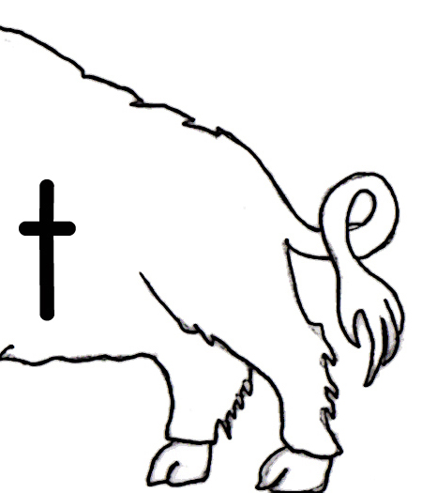

© 2009 Lanternfish ESL at www.bogglesworldesl.com

