Taking Medicine

First Listening: Listen to the instructions for taking medicine. What medicine is being described? Number the pictures below.
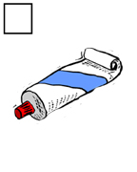 | 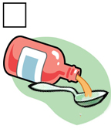 | 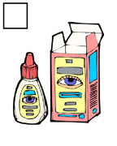 | 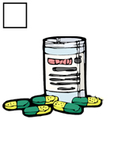

Second Listening: Listen again and fill in the blanks.
1. Take 1 ________________ every 4 hours for relief of ________________. Do not ________________ 4 tablespoons daily. If coughing lasts more than 1 week ________________ your doctor.

2. Take 1-2 ________________ as needed for ________________ of pain. ________________ 6 capsules daily.

3. ________________ ________________ to affected area of ________________. For ________________ use only.

4. Instill 1 or 2 ________________ in affected eyes every 3 or 4 ________________, or as directed by your ________________.

Taking Medicine: Script

1. Take 1 tablespoon every 4 hours for relief of coughing. Do not exceed 4 tablespoons daily. If coughing last more than 1 week see your doctor.

2. Take 1-2 capsules as needed for relief of pain. Maximum 6 tablets daily.

3. Apply cream to affected area of skin. For external use only.

4. Instill 1 or 2 drops in affected eyes every 3 or 4 hours, or as directed by your doctor.

