Dialogue: The Errands

Task 1: Answer the questions.
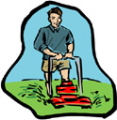 | 1. What does the daughter want? __________________________________________
2. Why was the dad going downtown?
___________________________________________________

3. What errands does the dad have to run?
___________________________________________________
___________________________________________________

Task 2: Fill in the blanks.
Erin: Dad, can you drive me to the store?
Dad: Sure. I have to go downtown anyway.
Erin: Why do you have to go downtown?
Dad: I have to run some errands.
Erin: What kind of errands?
Dad: I have to pick up some bread for mom and I have to stop by the bank.

