 A Sheet
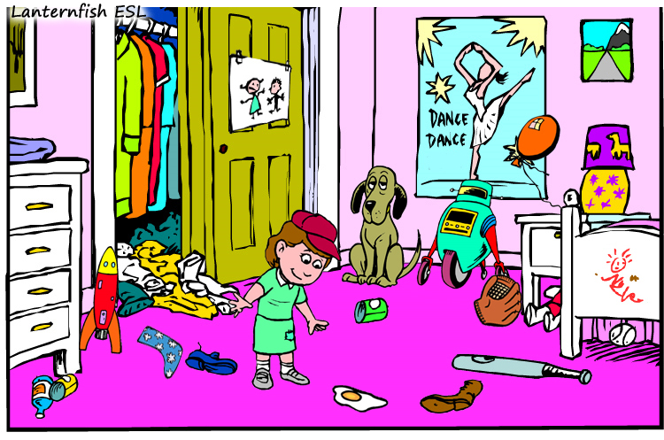
Describe your picture to your partner and try to find as many differences as you can. When you are finished compare your pictures and write down the differences that you found.
(1)
(2)
(3)
(4)
(5)
(6)
B Sheet
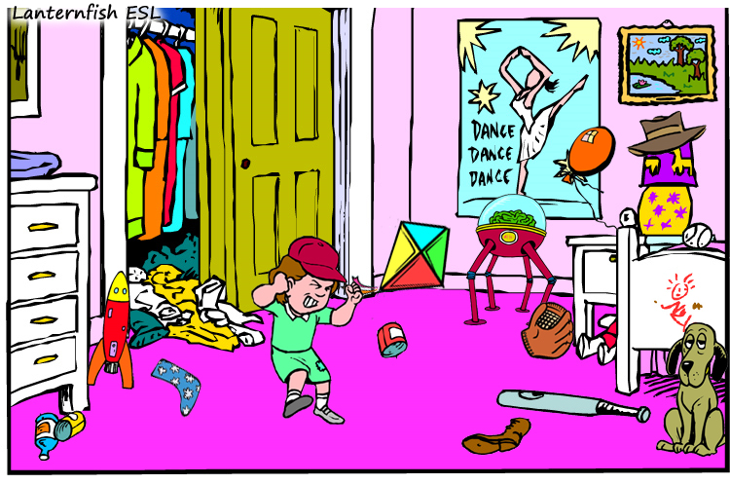
Describe your picture to your partner and try to find as many differences as you can. When you are finished compare your pictures and write down the differences that you found.
(1)
(2)
(3)
(4)
(5)
(6)

