Echinoderms and Symmetry

The words you need to know:
These are the words you need to know from this chapter: Highlight these words every time you come across them:

observe | echinoderm | symmetry
spines | sea urchin | brittle star
starfish | sea cucumber | sand dollar

Starting out:
Observe the pictures below. What does observe mean? It means to look at something very carefully. What do you observe? Can you see a pattern or anything in common? Write down your observations on the next page
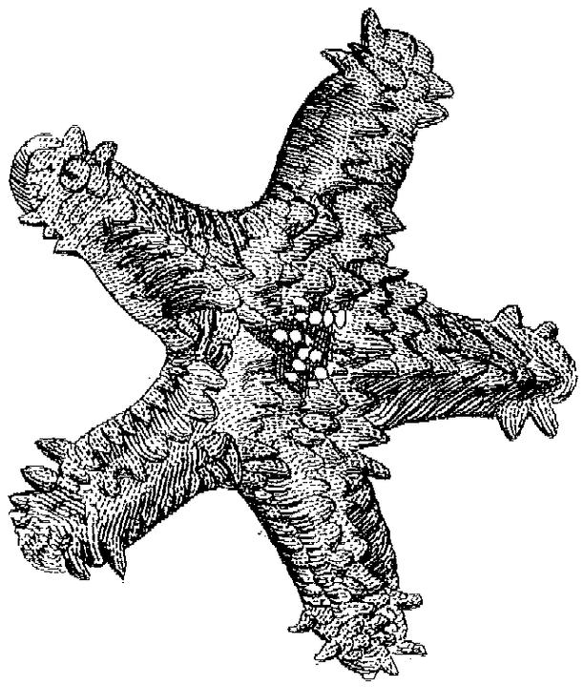 | 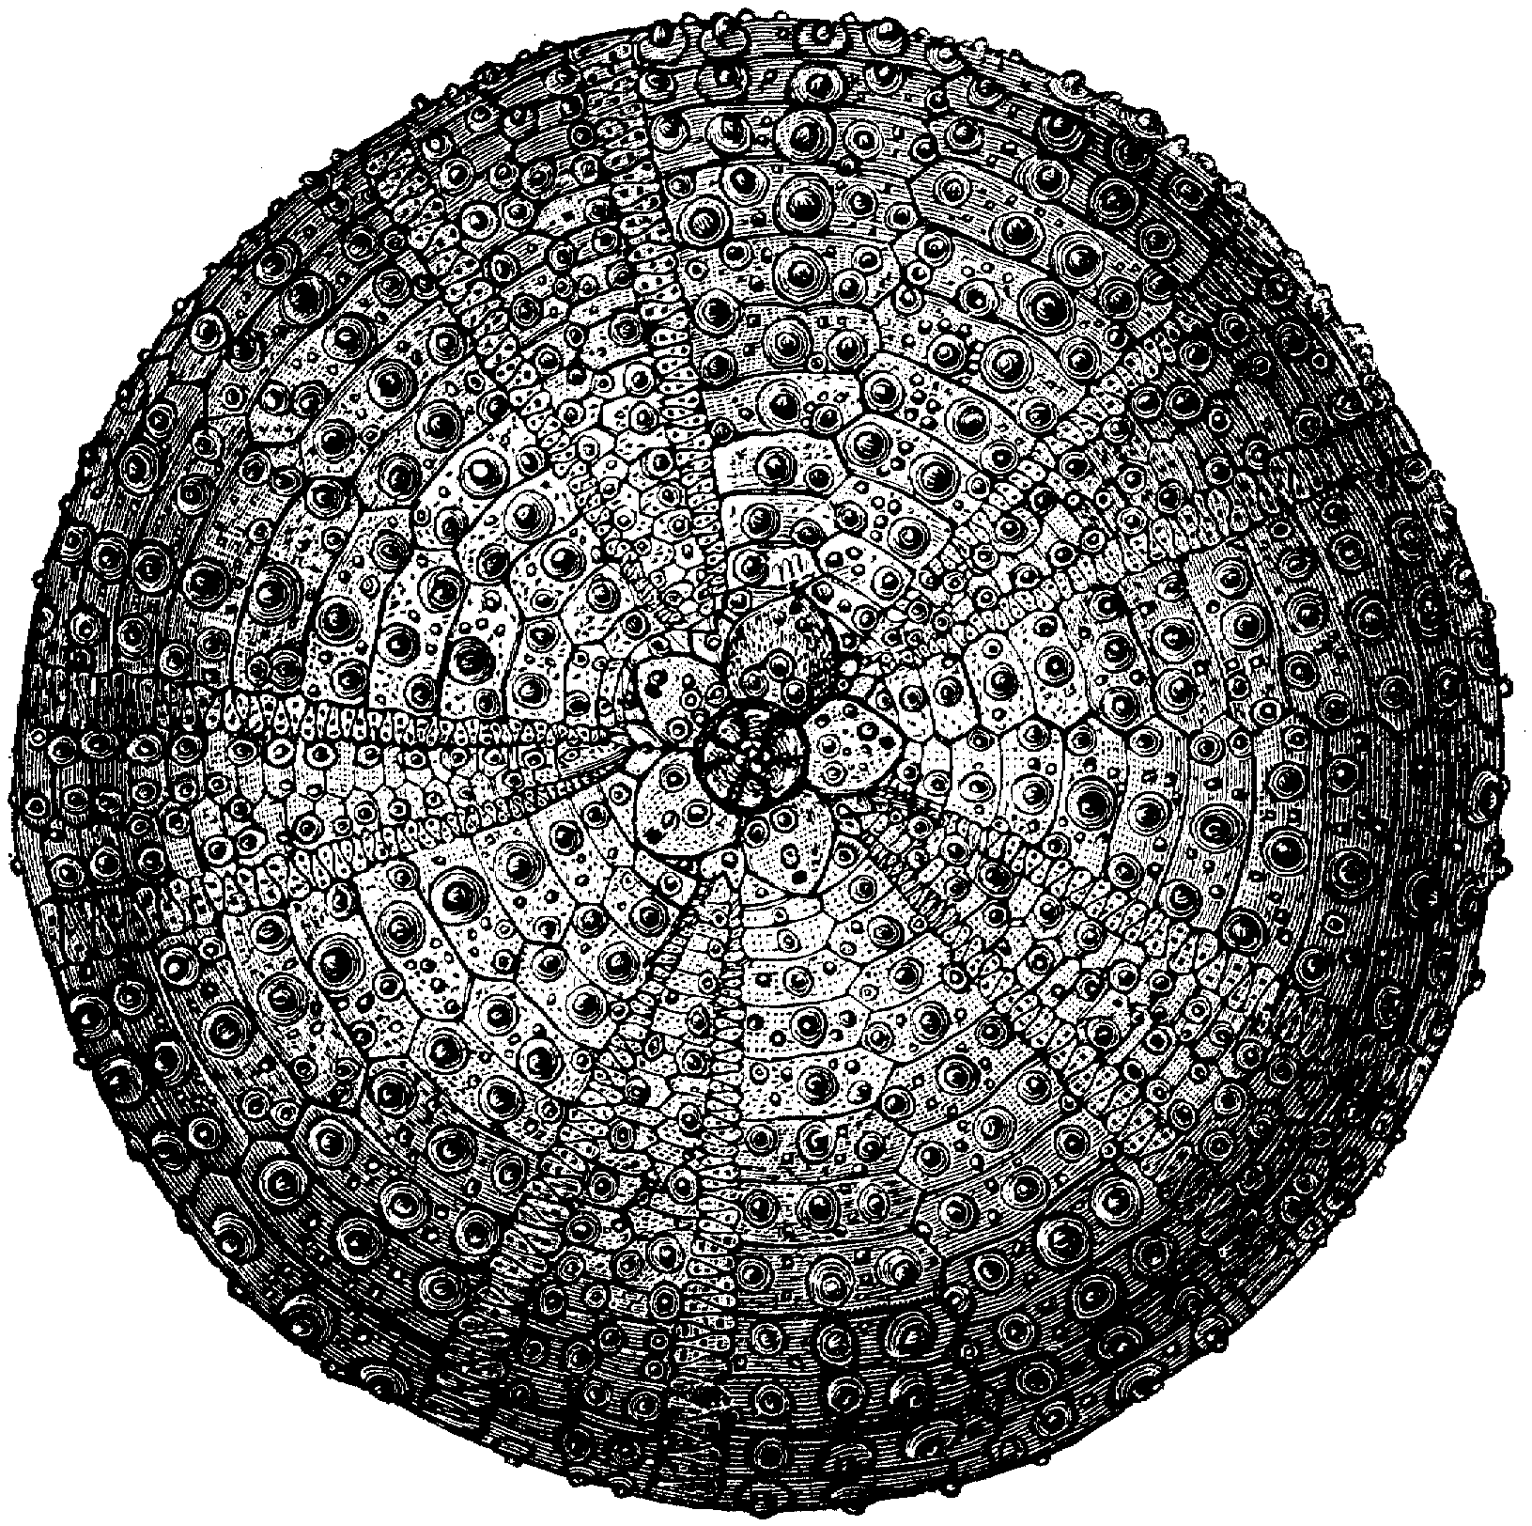 | 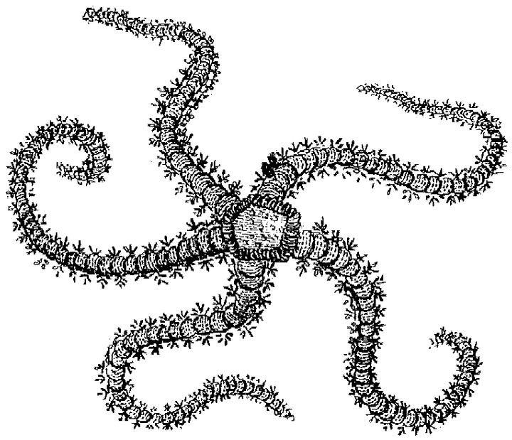
A Starfish | A Sea Urchin | A Brittle Star
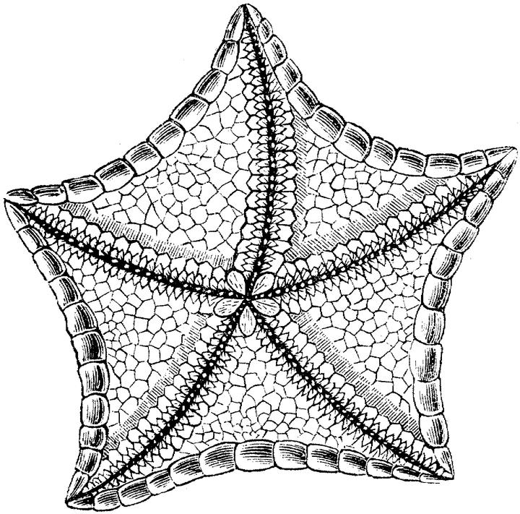 | 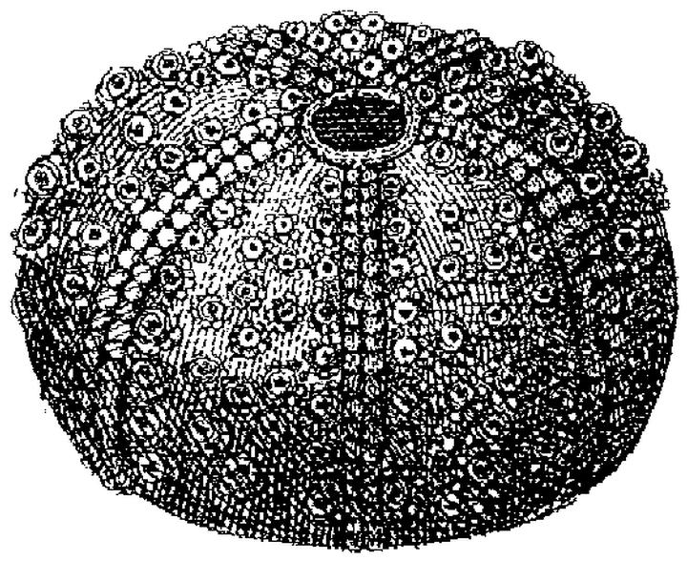 | 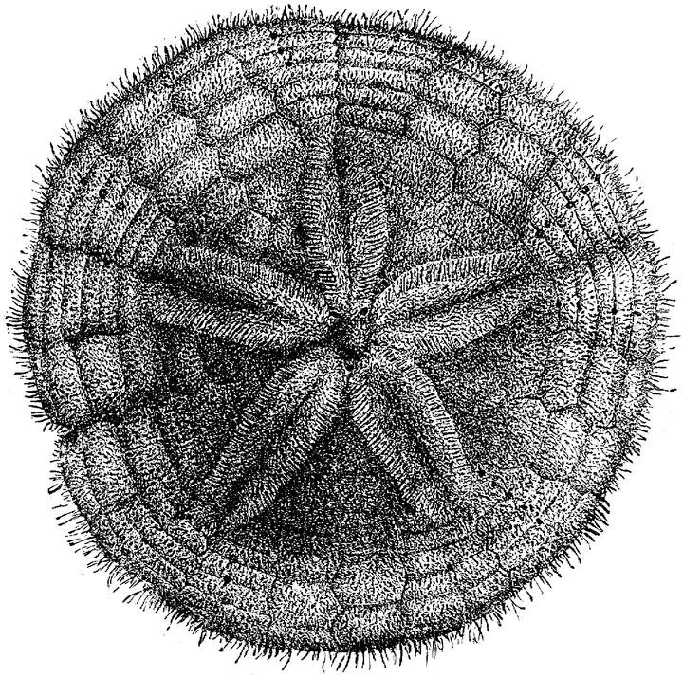
Another Starfish | Another Sea Urchin | A Sand Dollar
Did you highlight the important words for this chapter?
My observations:
What did you observe? Write down anything interesting that you observe in the pictures on the first page of this unit:

Guessing beforehand:
Without looking for the answers, try to guess the answers to these questions. Later you can check if your guesses were correct.

What do you think? Are these plants or animals?

Where do they live?

What do they eat?

Are they dangerous? Are they poisonous?

Can you eat them? Are they delicious?

Are there many of them?

Are they colorful?
(c) 2002 © www.bogglesworldesl.com
Read about it:

Echinoderms are animals that live in the oceans and seas. Echinoderm means spiny skin. Echinoderms are called ‘spiny skins’ because many of them have skin with spines. Not all echinoderms have spines, but many do. Actually, the pictures of the sea urchins that you saw on the other page were only the skeletons of dead sea urchins. When sea urchins are alive, they have many spines like the ones to the right. Circle some spines: | 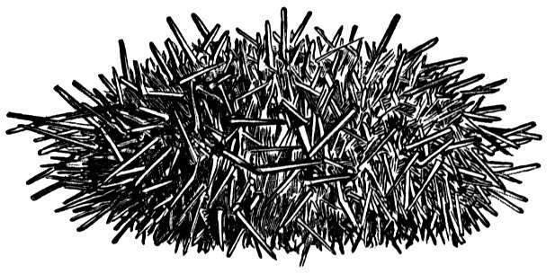
 | 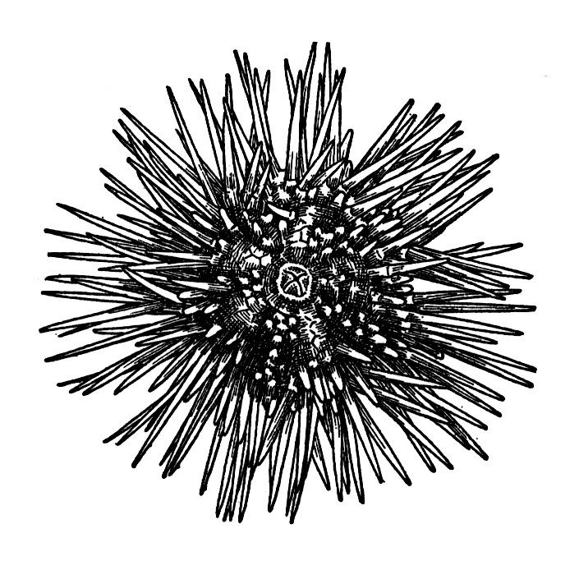
 | Living sea urchins with spines

Where do echinoderms live? They only live in saltwater seas and oceans. There are no echinoderms on land or in lakes and rivers. And most of them live at the bottom of the sea attached to rocks, unlike fish that can swim around. Also, echinoderms mostly live in shallow water, although some are found even in the deepest areas of the oceans.

Comprehension:

What does echinoderm mean?

Where do echinoderms live? (Did you guess that?)

Do all echinoderms have spines?

Do all echinoderms live in shallow water?

(c) 2002 © www.bogglesworldesl.com
Animals with Symmetry

Lines of Symmetry:  We are going to study symmetry. What does symmetry mean? Something is symmetrical if you can draw a line through it and it is the same on both sides of the line. That line is called a line of symmetry. Look at the mask. It has a line of symmetry drawn through it. | 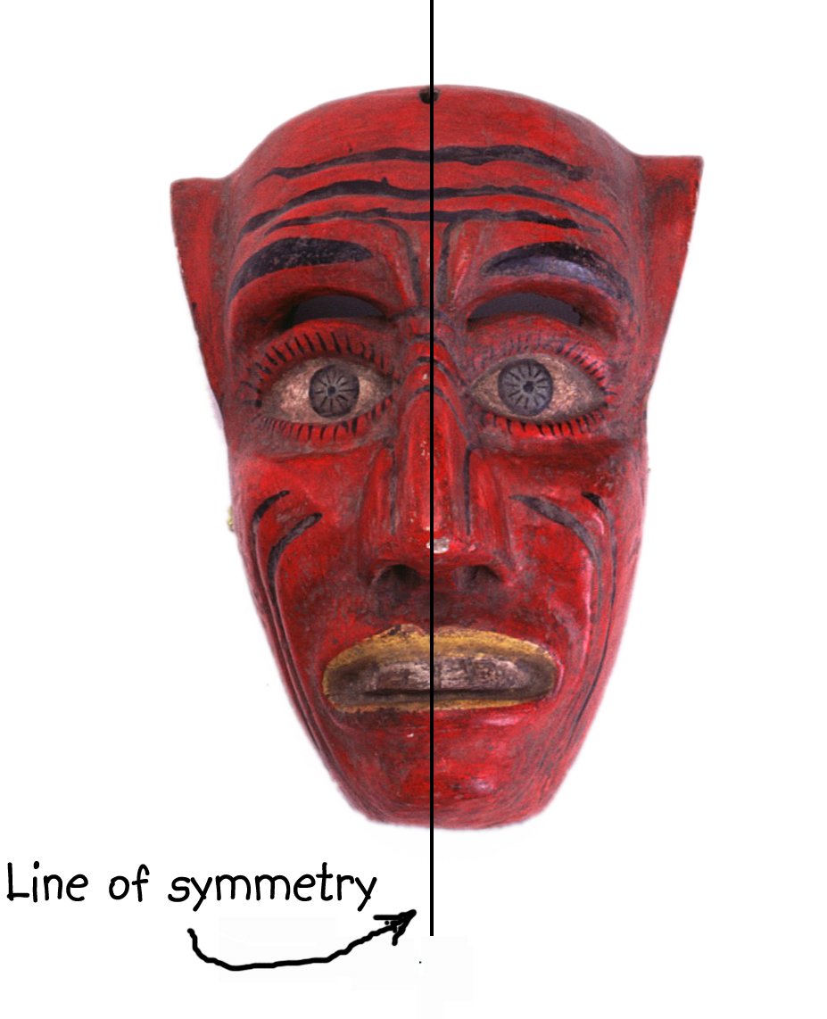

Do humans have symmetry?

How many lines of symmetry can you draw through a human?

How many lines of symmetry can you draw through an elephant, a tiger, a lizard, a bird, a dragonfly, a fish, or a frog?

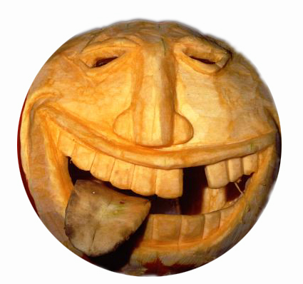 | Is this mask symmetrical?  Why isn’t this mask symmetrical?

(c) 2002 © www.bogglesworldesl.com
How many lines of symmetry do the echinoderms on page 1 have? Look at the starfish and sand dollar below. How many lines of symmetry can you count? Draw the lines of symmetry:

Four of the shapes below are symmetrical. Can you find them and circle them?

Two of these shapes have more than one line of symmetry. Can you find them?

(c) 2002 © www.bogglesworldesl.com

