Mollusks – Protecting a Soft Body

The words you need to know:
These are the words you need to know from this chapter: Underline these words every time you come across them:
mollusk | invertebrate | gastropod | bivalve
cephalopod | snail | octopus | nautilus
scallop | mussel | limpet | oyster
slug | clam | conch | squid

Mollusks:
In this unit we are going to study mollusks. There are four kinds of mollusks but we are only going to study three kinds of mollusks. Below are some examples of mollusks. Observe them carefully. What is special about each kind of mollusk?

Cephalopods: | 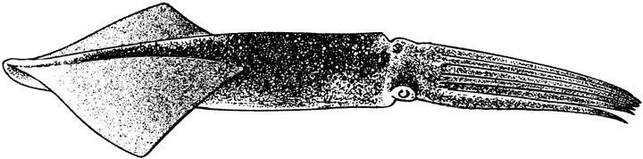 | 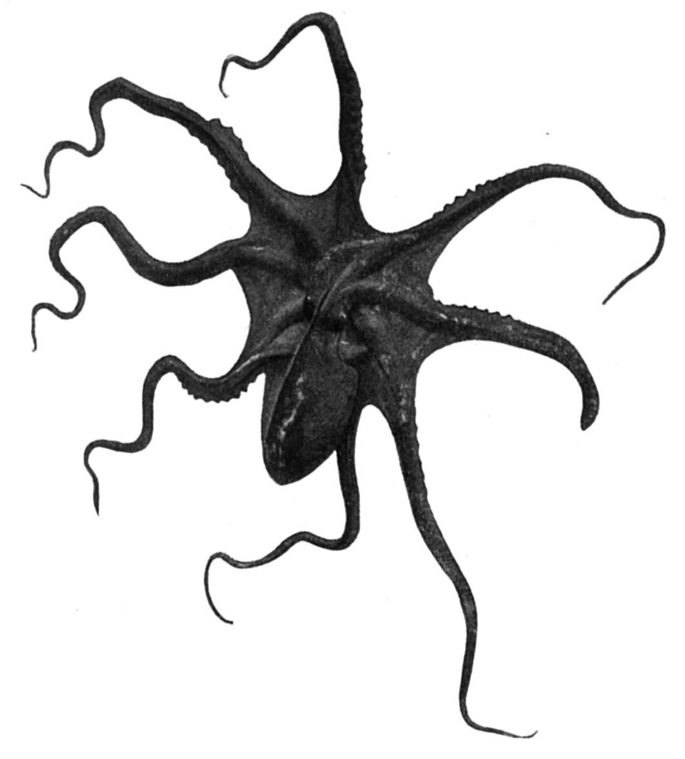
 | squid | octopus
Gastropods: | 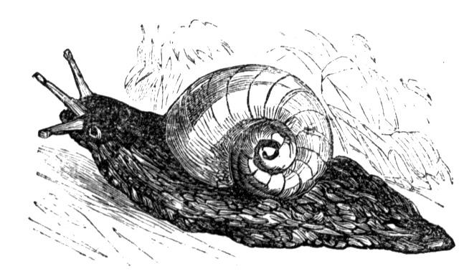 | 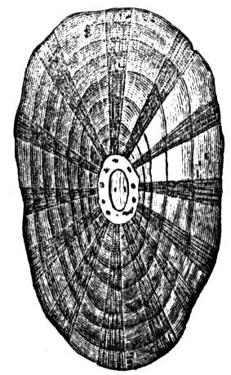
 | snail | limpet
Bivalves | 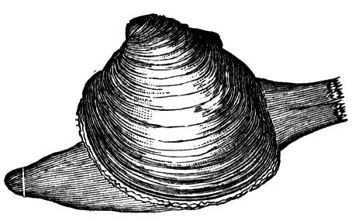 | 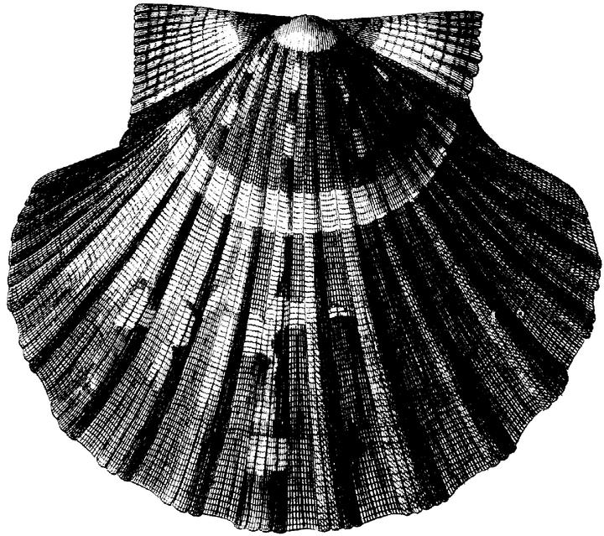
 | clam | scallop
(c) 2002 www.bogglesworldesl.com
My Observations:

Cephalopods

Gastropods

Bivalves

Definitions:
Now that you have observed three kinds of mollusks, try to make a definition for each kind. Start your definition like this:

A _____________ is a mollusk that __________________
(1)

(2)

(3)

What is a mollusk?
A mollusk is an invertebrate. An invertebrate is a soft-bodied animal that has no backbone. Crabs, insects and jellyfish are also invertebrates but they are not mollusks. Mollusks are special because they all have a soft body that is divided into three parts, a head, a body and a foot. Most mollusks have a shell, but not all of them. Some mollusks, such as snails, are head-body-foot. Other mollusks, such as octopuses, are body-head-foot. Here are two examples:
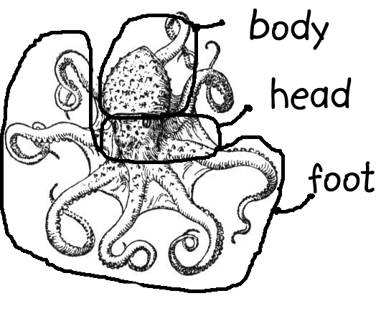 | 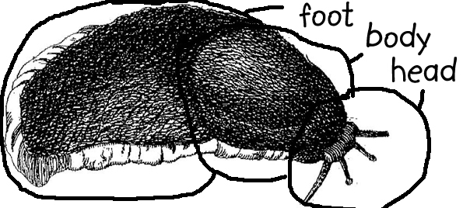
body-head-foot | head-body-foot
Appearances Can Be Misleading:
Some people define mollusks by their appearance. Appearance means how they look. For example, they classify the mollusks by the number of shells that they have:
A cephalopod is a mollusk that has no shell.
A gastropod is a mollusk that has one shell.
A bivalve is a mollusk that has two shells.

Look at the definitions above. According to your definitions, what kind of mollusks are these animals? What kind do you really think they are?
Look at the two mollusks to the right. | 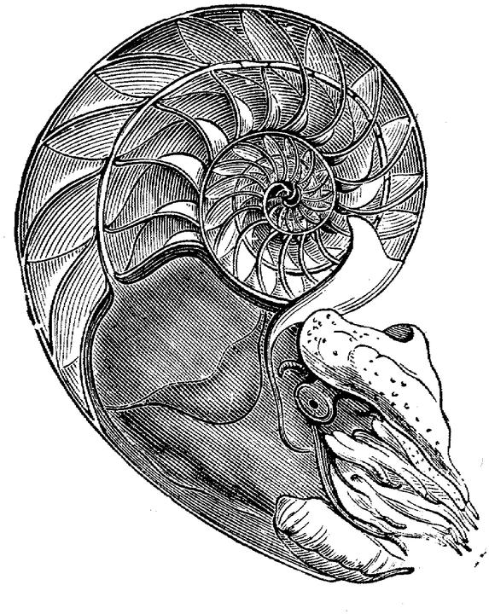 | 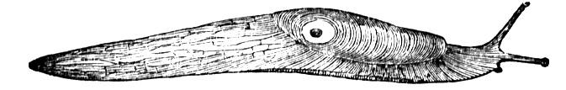
 | nautilus | snail
According to the definition they are:

I think they are:

The Problem with Using Appearance to Classify Animals:

A nautilus has a shell but it’s a cephalopod. Observe carefully and you will see its many legs coming out of its shell. A slug doesn’t have a shell but it’s a gastropod. So saying ‘a cephalopod is a mollusk with no shell’ or ‘a gastropod is a mollusk with one shell’ is not a good way to classify animals.

Instead, biologists look at the insides of the animals. They look at the organs like hearts and stomachs. But still, outside appearances can help: Most gastropods do have only one shell. And most cephalopods do not have any shell.

(c) 2002 www.bogglesworldesl.com
Soft Muscular Bodies: Mollusks are Good to Eat.

Most people like to eat some kind of mollusk. Their soft muscular bodies make them easy to eat and delicious. |  |  | How to Cook ___________  ingredients:
Which of these mollusks have you tried? Which do you like? |  |  | cooking instructions:
Mollusk | Tried? | Like? | cooking instructions:
squid  octopus  mussel  clam  oyster  snail  slug  nautilus  scallop  limpet |  |  | cooking instructions:
For homework, search the internet or ask your parents for a good recipe for cooking one kind of mollusk. Make a class mollusk cookbook. -----> |  |  | cooking instructions:

(c) 2002 www.bogglesworldesl.com
Protecting Their Soft-bodies: The Marvelous Methods of Mollusks

Mollusks have soft bodies, which makes them easy prey for many other kinds of animals. And so, mollusks have evolved many ingenious ways to protect themselves.

On way that mollusks protect themselves is to build a hard shell around their bodies. Clams, oysters, snails, mussels, and scallops all have shells. As long as the shell is not broken, it is hard for other animals to eat them.

Another way that mollusks protect themselves is through camouflage. The octopus can change the color of its skin to look like its surroundings perfectly. If other animals can’t see the octopus, then they won’t attack it. Some octopuses are even better at camouflage than chameleons.
A third way that some octopuses and squids hide themselves is through a ‘smoke screen’. They shoot a jet of ink into the water to confuse a predator, while the squid or octopus escapes. | A squid shooting ink  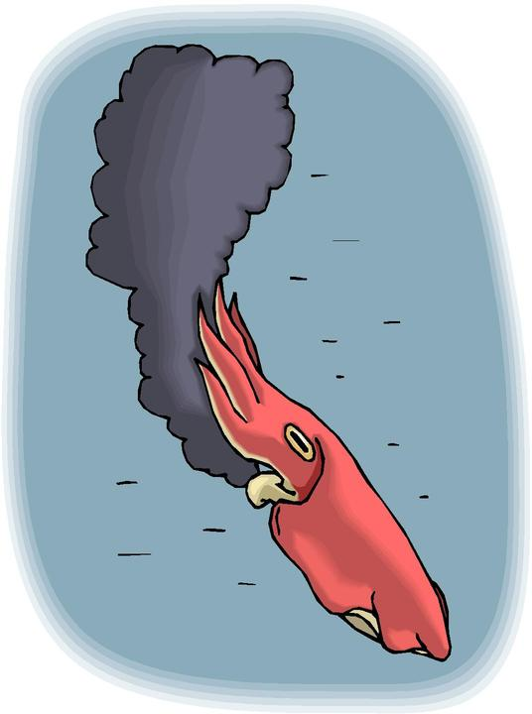
A fourth way that mollusks protect themselves is through poison. Both the cone snail and the blue-ringed octopus have a very deadly poison that can paralyze people or even kill them. They may look small and cute, but they are very dangerous.

And yet another way that mollusks protect themselves is through jet propulsion. Both scallops and squid can shoot water through their bodies to make them move very quickly to escape predators.

Finally, some mollusks protect themselves by tasting so terrible no other animal will eat them. The very colorful sea slugs, called nudibranchs, are an example. The bright color is a warning to other animals that they taste really bad.

Comprehension questions:

Why did mollusks have to develop many ways to protect themselves?

What are some mollusks that make shells?  What is camouflage? What mollusk uses it well?  What mollusk shoots a jet of ink? | 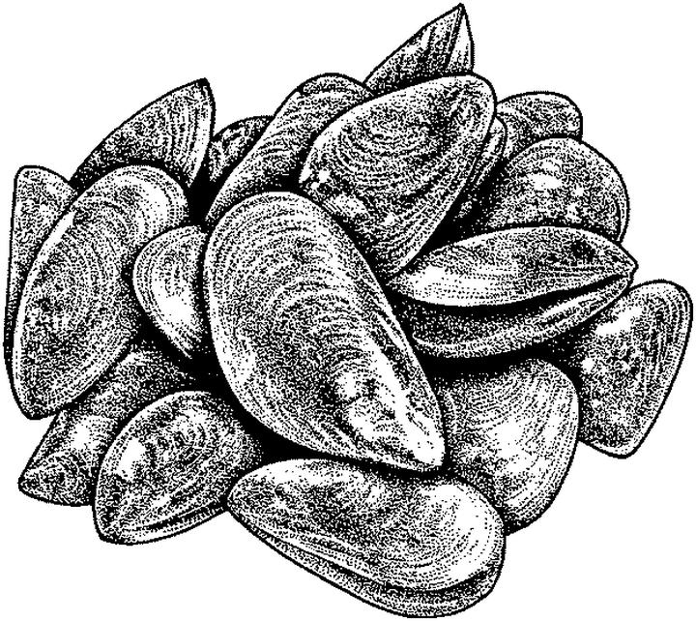  mussels

Why is the blue-ringed octopus dangerous?  How do scallops escape from starfish?  What mollusks taste so terrible that nothing will eat them? | 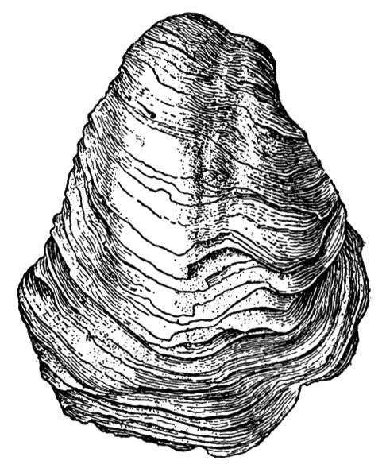  an oyster

How do these mollusks warn other animals that they taste terrible?

Organizing Your Thoughts: Fill in the Chart
Method of Protection | Example of Mollusk Using this Method

(c) 2002 www.bogglesworldesl.com

