Language: | How many are/were left?  How many are/were remaining?  How many remain/remained?
Example: Dracula had nine apples. He gave three apples to the werewolf. He also gave two apples to the mummy. Then he used three apples to bake a pie. How many apples are left? ANS: one

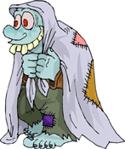 |  | The ogre had a blanket shop. On Monday, he had fourteen blankets for sale. That day, he sold four blankets. Then on Tuesday, he sold another five blankets. How many were remaining in his shop on Wednesday? ANS: ___________
Frankenstein got sixteen lollipops for his birthday. He had four friends. He gave two lollipops to each friend. He dropped one on the ground and threw it away. And he ate four lollipops himself. How many did he have left?  ANS: _____________ |  |  | 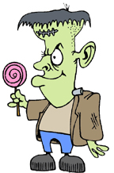
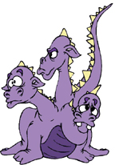 |  | Max, the three-headed hydra, got eleven steaks for dinner. The first and third heads ate two steaks each. The second head ate three steaks. How many steaks remained? ANS: ___________
The swamp monster caught twenty-six fish in the morning. It ate three fish for breakfast. It ate five fish for lunch. It ate four fish for dinner. And it sold ten fish in the market. How many fish are left? ANS: ____________ |  |  | 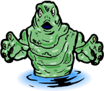
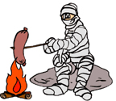 |  | The mummy brought thirty-two hotdogs to a picnic. He cooked fourteen and ate them. He fed six to his pet dragon. Some giant ants took 5 when the mummy was asleep. How many hotdogs remain? ANS: _____________
(c) 2003 www.bogglesworldesl.com

