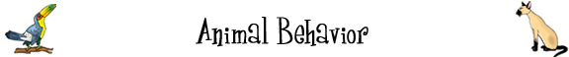
Fill in the grid with words related to animal behavior.

Across
5. Animals that move long distances for the winter or summer.
6. An animal with a shell on its back.
7. Animals that live in groups.
8. Animals that do not exist anymore.
9. Animals that live with humans.
12. Sleep during the winter.
Down  1. Active at night.  2. Animals that live in water.  3. Animals that live on land.  4. The opposite of wild.  6. Animals that defend a territory.  8. Animals that might go extinct in the future.  10. Animals that live in the oceans or seas (salt water).  11. Animals that live alone. | 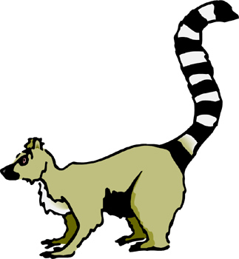
© 2006 Boggle’s World

