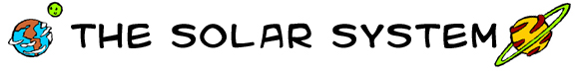
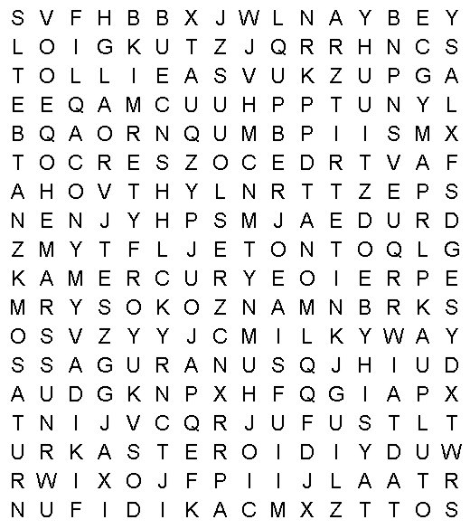 |  |  | 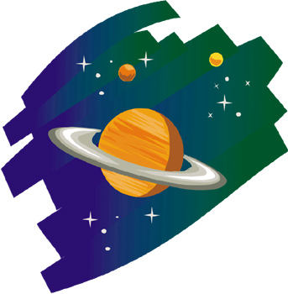
solar system  Sun  Mercury  Venus  Earth  Moon | Mars  Jupiter  Saturn  Uranus  Neptune  Pluto | asteroid  comet  meteor  crater  rings  Milky Way
www.bogglesworldesl.com

