
Find rhyming words that match the clues:  (1) What flowers do that rhymes with mud.  (2) What flowers do that rhymes with room.  (3) What plants do that rhymes with pout.  (4) A spring blossom that rhymes with hairy.  (5) A spring flower that rhymes with hill.  (6) A spring flower that rhymes with sip. |  | 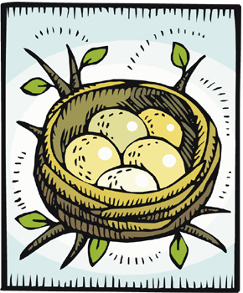
(7) What birds lay that rhymes with legs.

(9) What a bird builds that rhymes with best.

(10) What eggs do that rhymes with match.

(11) What farmers plant that rhymes with weeds.

(12) A month in spring that rhymes with day.

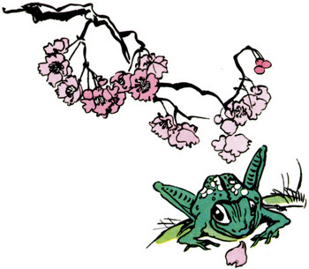 | (13) A month in spring that rhymes with parch.  (14) A day for tricks that rhymes with pools.  (15) A spring rain that rhymes with flower.  (16) What snow does that rhymes with pelts.  (17) An animal that wakes in spring and rhymes with hair.
© 2006 www.bogglesworldesl.com

