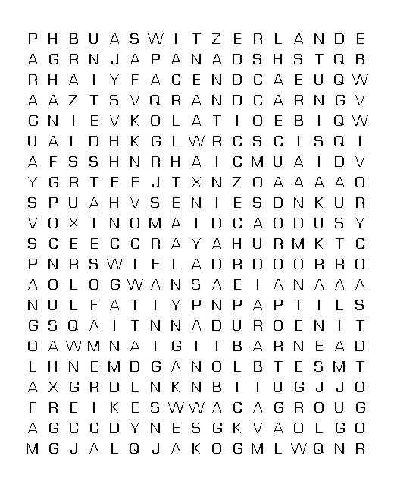 |  |  |  |  | 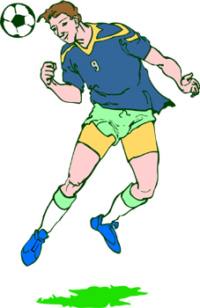  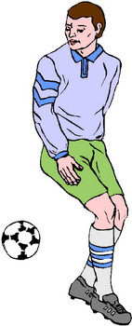
Group A  Germany  Poland  Costa Rica  Ecuador | Group B  England  Paraguay  Trinidad and Tobago  Sweden | Group C  Argentina  Ivory Coast  Serbia and Montenegro  Netherlands |  | Group D  Mexico  Iran  Angola  Portugal
Group E  Italy  Ghana  United States of America  Czech Republic | Group F  Brazil  Croatia  Australia  Japan | Group G  France  Switzerland  South Korea  Togo |  | Group H  Spain  Ukraine  Tunisia  Saudi Arabia

© 2006 www.bogglesworldesl.com

