The Opening Ceremony
Today is the beginning of the Summer Olympics in Beijing. Ping and Yoyo are very excited. They are visiting Ping’s grandmother in Beijing, and later this week they can go to see some of the Olympic sports competitions.
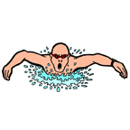
Tonight is the opening ceremony. That’s the ceremony when all of the athletes from all of the countries come together. And, it’s when dancers and singers will perform for all of the people visiting from all over the world. While they wait for the ceremony to start on TV, Ping and Yoyo talk about what sports to watch later.

Ping: I want to watch gymnastics. What about you?

Yoyo: I’d like to see the equestrian games. I don’t like gymnastics much.

Ping: What about swimming? Shall we watch that?

Yoyo: Yes, let’s watch swimming and let’s watch ping pong.

Ping: I love ping pong! But I don’t like to watch tennis, do you?

Yoyo: No I don’t like tennis much. But I do want to see hurdles, running and those kinds of sports.
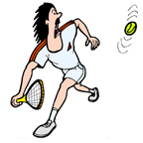
Ping: Those kinds of sports are called track and field.

Yoyo: Okay! Let’s watch track and field!

Ping: Shhh…the opening ceremony is starting!
Track and Field

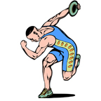
Ping and Yoyo are excited to be going to the Track and Field competitions at the Beijing 2008 Summer Olympics.

They go to the stadium early and watch some of the athletes.

Ping: Look at that woman! She is so strong and tall. Maybe she is a discus thrower.

Yoyo: Yeah! She has so many muscles!

Ping: What about that guy? His legs are so long. Maybe he competes in hurdles?

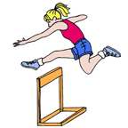
Yoyo: No, I think he might be in the pole vault competition. Or the high jump.

Ping: Wow, I think that’s so hard!

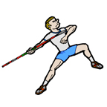
Yoyo: What are some other track and field competitions?

Ping: Well, there’s also javelin, hammer throw and wrestling.
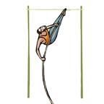
Yoyo: I’m excited, let’s watch!

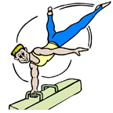
Gymnastics

Ping and Yoyo are back at the Beijing 2008 Summer Olympic Games. This time, they’re going to watch gymnastics.
Yoyo doesn’t like gymnastics much, but Ping wants to see them, so Yoyo agreed if they could watch some swimming later.

Ping: Yoyo, isn’t this exciting? We’re so lucky to see the Olympics.

Yoyo: I know! I’m glad we bought these Chinese flags to wave. We can yell really loud when China wins!
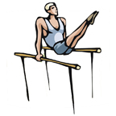
Ping: Great! Now, today we’re watching gymnastics.

Yoyo: What kind of gymnastics?

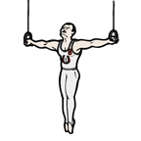
Ping: Well, first we’ll watch the pommel horse. Those athletes are amazing! Their arms are really strong. Then, we’ll see the parallel bars. I think it’s cool how the athletes almost fly in the air. And finally we’ll watch the rings.

Yoyo: Rings? We’re going to buy some jewelry?

Ping: No, the rings! There are two rings hanging down and the athletes perform on them. You’ll see.

Yoyo: Okay. I guess I’m going to learn a lot today!

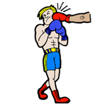
Fighting Sports
Yesterday, Ping and Yoyo watched gymnastics at the Beijing 2008 Summer Olympic Games. Today, they want to watch some of the fighting sports. They think it will be exciting.
Ping: Hey, Yoyo, what are we watching today?

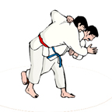
Yoyo: We’re going to watch some of the fighting sports, like taekwon-do, karate and judo.

Ping: Are those like kung fu?

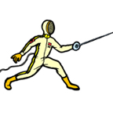
Yoyo: No, they’re different. Kung fu is from China, but Tae kwon-do is Korean and Karate and Judo are Japanese.

Ping: Oh. What other kinds of fighting sports can we watch?

Yoyo: There’s fencing—they use swords. There’s shooting—they use guns, and boxing. Boxers use their fists.

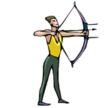
Ping: Wow! That’s cool. Hey, what about archery?

Yoyo: Archery is like shooting, but the athletes use a bow and arrow.

Ping: Let’s see that first. I think it starts soon!

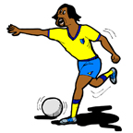
Ball Sports

Ping and Yoyo have one more day to watch the Olympics before they have to go home. They want to watch some sports that China is good at.
Yoyo: Hey Ping, today we should watch some team sports.

Ping: Like ping pong? I love watching the Chinese team play ping pong.

Yoyo: Me too, but I was thinking more about volleyball. Do you like volleyball?

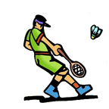
Ping: Yes, I like volleyball a lot. What about badminton.

Yoyo: Badminton is good too. I can play badminton, can you?

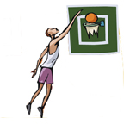
Ping: Yes, a little but I’m not very good.

Yoyo: Hey, let’s go see the basketball matches too.

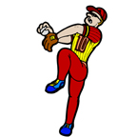
Ping: And the soccer!

Yoyo: What about baseball?

Ping: I think baseball is boring.You?
Yoyo: Me too. But what about field hockey?

Ping: I’ve never watched field hockey.

Yoyo: Me either. Let’s go there now!

Ping: Sounds good!

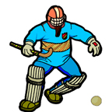

Going home

The Olympics are over, and Ping and Yoyo are going home. They are on the train. They are talking about what they saw over the last two weeks.
Yoyo: What was your favorite sport?
Ping: It was the archery. I think it’s interesting. Maybe I can take archery lessons this year!
Yoyo: Really? I think my favorite was the pole vault. I think it’s beautiful when the athletes jump so high. It’s like they’re flying!
Ping: That’s right. They do look like they’re flying! I also liked watching the karate and taekwondo. I don’t know which I like better.
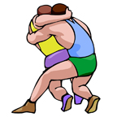
Yoyo: Did you like the wrestling?
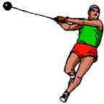
Ping: No! The men were too strong. I thought they were ugly.
Yoyo: I liked it. I also liked the discus and hammer throwing. Those people are strong and amazing. Like superman!
Ping: Maybe. What sports will you play this year?
Yoyo: I want to start to play soccer.
Ping: But boys play soccer!
Yoyo: I think girls can play too! I am fast. I think I can be a good soccer player!
Ping: I think you’d be better at basketball or volleyball.
Yoyo: Maybe. But I like to run. Maybe I should do hurdles!
Ping: Maybe! But I don’t think you can jump!
Yoyo: Yes I can! I can jump higher than you!

