A Sheet 
Language Points | 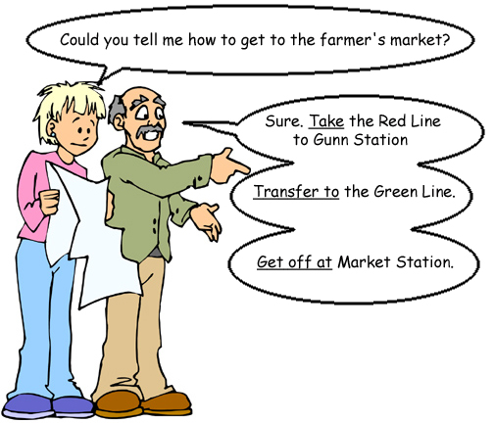 | 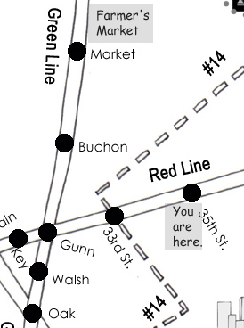
Take
Take the Green Line to Oak Station.
Take the #14 Bus to 25th Street.
Transfer to
Transfer to the red line.
Transfer to the #3-1 bus.
Get off at
Get off at Market Station.

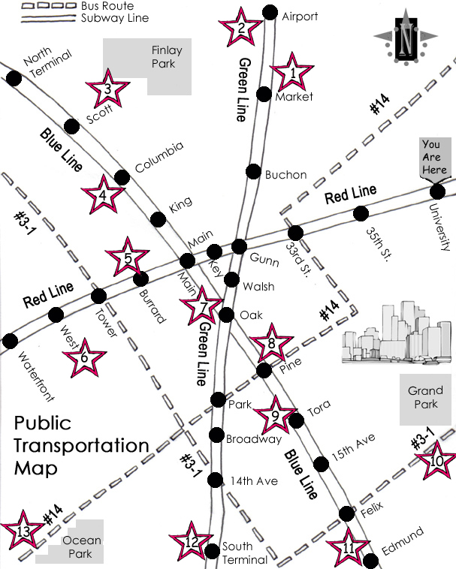  Use this map to give your partner directions. | Ask your partner how to get to the following places:  The Public Library  SunMyeong Castle  St. Paul’s Cathedral  The Airport  The Bus Station  GorWat Temple
 | Fill in the name of the buildings that belong in the blanks:
 | (1) | Farmer’s Market
 | (2)
 | (3) | Newport Casino
 | (4)
 | (5) | The Grand Hotel
 | (6)
 | (7) | National Art Museum
 | (8)
 | (9) | The Train Station
 | (10)
 | (11) | Three Rivers Park
 | (12)
 | (13) | Henry’s Department
 |  | Store
© 2005 www.bogglesworldesl.com
B Sheet
Language Points
Take
Take the Green Line to Oak Station.
Take the #14 Bus to 25th Street.
Transfer to
Transfer to the red line.
Transfer to the #3-1 bus.
Get off at
Get off at Market Station.

Use this map to give your partner directions. | Ask your partner how to get to the following places:  The Grand Hotel  The National Art Museum  Henry’s Department Store  Three River’s Park  Newport Casino  The Train Station
 | Fill in the name of the buildings that belong in the blanks:
 | (1) | Farmer’s Market
 | (2) | Airport
 | (3)
 | (4) | The Public Library
 | (5)
 | (6) | The Bus Station
 | (7)
 | (8) | St. Paul’s Cathedral
 | (9)
 | (10) | GorWat Temple
 | (11)
 | (12) | SunMyeong Castle
 | (13)
© 2005 www.bogglesworldesl.com

